Cost is $20.00 per person
Drivers name: ___________________________ RK Chapter: _________________
Phone #: ________________________ E-Mail: ____________________________
Mailing Address: ____________________________________________________
_____________________________________________________
Passenger Name: ____________________________________________________
Other Guests: _______________________________________________________
Additional Events:
Friday Night Dinner @7pm (Location TBD) Number of attendees: ___________
Saturday Morning Group Ride, Number of attendees: ___________
Participating in Poker Run? (during morning ride) Additional $10 per player
Number of Poker Run Players: _________________
Payments can be made to PA 2 Treasure (Dowlin) Via these payment methods
Check or Money order Payable to: Red Knights Pa2
Mailing Address:
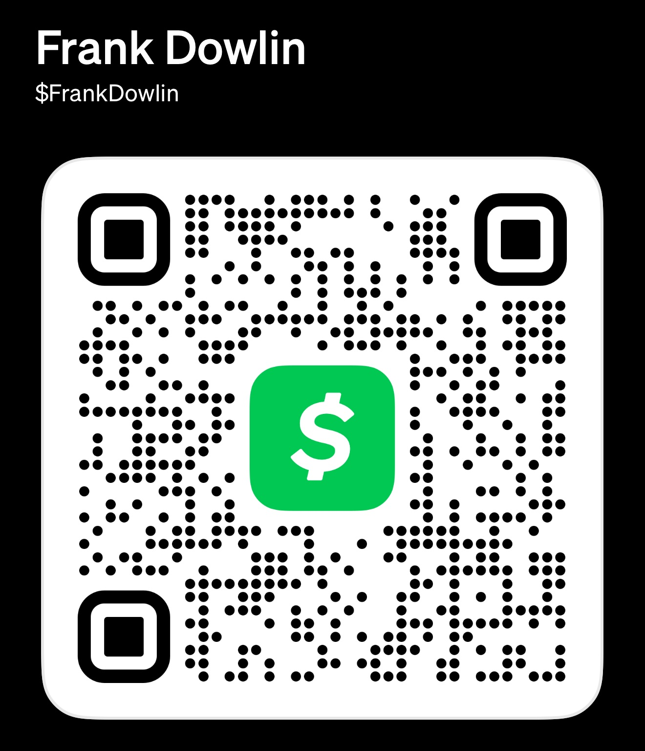
Douglas Dowlin
114 S. 13th Ave Apt 2
Coatesville Pa. 19320
Pay Pal @DouglasDowlin
Cash APP: Scan link to the right ->
Please mail completed form to address above or E-Mail to:
Pa2@redknightsmc.com

